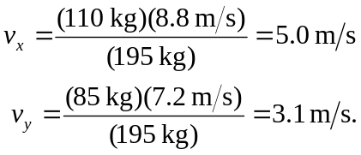8.30: Take north to be the x-direction and east to be the y-direction (these choices are arbitrary). Then, the final momentum is the same as the intial momentum (for a sufficiently muddy field), and the velocity components are

The magnitude of the velocity is then 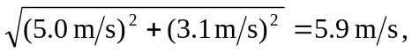 at an angle or arctan 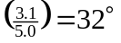 east of north.

